LAB 6

MVC

1. The goal of the MVC Design pattern is to separate the application from the way it’s represented to the user from the way the user controls it.

This is opposed to putting it all together and provides more modularity and adaptation of the GUI.

2. A design pattern is a way of reusing code from different projects in object-orientated programming.

i.e. its kind-of a database of commonly used patterns, or a 'class' of pattern

3. 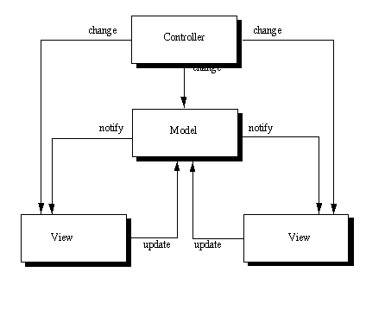

4. The main components of MVC are Model, View and Controller. Model is at its basic essence the shape of the pattern, View encompass the colours and graphics and Controller deals with the moving parts or actions, and how the components interacts with the user.

5.

Min/max data - a min max data im going to talk about for scrollbars where the model would be to increase once up until it hits its maximum.

The view could be the bars itself i.e. size shape translucence but would always do the same thing because it has been set down in the model.

And the controller could have the mouse click to move up the scrollbar or down or even jump several increments at once.

Clock timer - an example for the clock, the model would be what it does i.e. keep time by increasing the second hand every second, the minute every 60 seconds and the hour every 60 minutes

The view would be the exact appearance of the clock i.e. is it digital or analogue? Or something completely different like a sundial as long as it shows its data it can be changed to be any colour or size.

The controller might have an option for setting the time increase or decreasing it manually.

6. Six advantages are: multiple view design, easier support for client types, and clarity of design, modularity, and ease of growth and distributable.

Personally I find modularity to be the key here as most of the advantages hinge on it the beauty of being able to change one section and have the whole concept change without making the other half break.

7. Swing introduced UI to MVC, it did this using more of a linier pattern than the traditional MVC.

It does this by collapsing the view and controller parts of the model into a single UI 'object'.

It makes it possible to edit sections a lot easier and change the "look and feel" with only a few minor changes.